Remote Control Human Response Circuit
Nicholas Foulk
Computer Engineering Department, College of Engineering
San Jose State University, San Jose, CA 94303
E-mail: nickfoulksjsu@gmail.com

Abstract
The objectives of this project was to install two LEDs and a TSOP 31236 for creating a remote control circuit. One of the LEDs was used for signifying the remote control system was active. The second LED was used for testing the response time of a participant. The programming of the LPC1769 involved the LPCXpresso IDE and consisted of functions dealing with interrupts and timers. The second LED would light up at random times and the participant would click a button on a remote to turn off the LED.

- Introduction

The TSOP 31236 had a very lenient circuit in order to function. There was an additional circuit provided by the data sheet to reduce electrical over stress within the component, but isn’t necessary for minimal use. The TSOP had only three pins, output, voltage supply and ground. The TSOP runs at a carrier frequency of 36 kHz.
To utilize the infrared receiver with an LPC 1769 for turning off and on an LED, interrupts have to be implemented. The program requires a functions to initialize, reset and halt a timer whenever a signal has been received by the TSOP and record a response time from the time between the LED turning on and a signal turning it off. The demonstration requires a few trials in each test and the LED needs to turn on random times to prevent predictability of the participant.

2. Methodology

The objectives and technical challenges will include the overall outcome and problems faced in this project. The problem formulation and design will break down the process of identifying the problem and planning out a solution.

2.1. Objectives and Technical Challenges

The objective of this project was to calculate the average and standard deviation of the all the response times measured in a given test. One of the LEDs had to stay on and the other had to turn on and off to measure how fast the participant can turn it off. The technical challenges faced included programming the timing functions and taking only one response per trial in a given test.
The goals of this human response time test project included making revisions and tweaks to produce a well written program and a sustainable circuit for industry practice. Another goal of this project was to learn all of the functions of a timer for the LPC 1769 CPU and gain more experience with the NXP LPCXpresso IDE to program.

  - Problem Formulation and Design

The problem proposed when setting up the prototype board with a TSOP 31236 was providing a circuit with an infrared receiver system to test the process of using interrupts for the LPC 1769 Module and implementing a timer:
- In order to provide the TSOP 31236 with 3.3V, the LPC 1769 module pin J6-28 was used and it allowed the circuit to be powered entirely off of the USB connection to the computer. The TSOP 31236 could handle anywhere between 0 and 6.0V according to the absolute maximum ratings provided by the datasheet.
- The biggest problems faced with when using a TSOP 31236 is taking handling the multiple responses received per trail and handling the LED switching. Initializing and rewriting the interrupt functions proved to be tedious and vague when approaching the task.

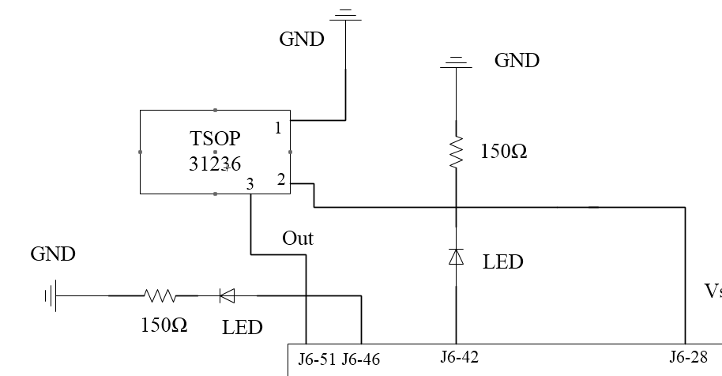
Figure 1: System block diagram of the TSOP and LEDs

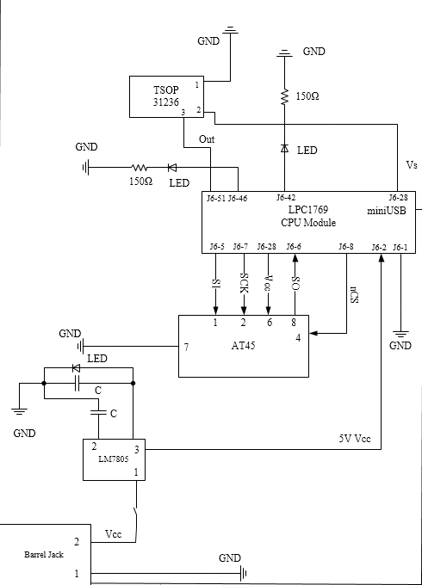

Figure 2: Overview picture of the prototype board with the TSOP circuit and other previous circuits used in projects.
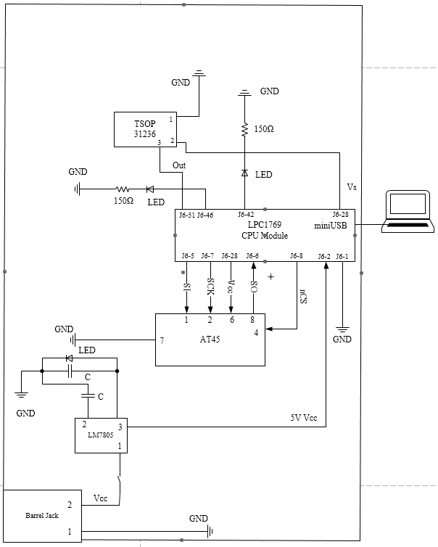
Figure 3: System Layout of prototype board.

3. Implementation

This section provides the hardware design, and software design to implement the two LEDs and TSOP circuits integrated with the LPC 1769 Module. The hardware design includes a system block diagram, a schematic design, and a list of components used. The software design includes flow charts, algorithms, and pseudo code for describing the process of designing the coded program.

3.1. Hardware Design

The design of each system block diagram and schematic design represented in the Problem Formulation and Design section are explained here. This section also includes a Bill of Material used for the project.
- In Figure 1 there is a TSOP 31236 and two LEDs connected to three individual GPIO pins. The TSOP 31236 is using the 3.3V power supply on pin J6-28 on the LPC module. The LPC module is powered with a USB connection to the computer. The output of the TSOP is connected to pin J6-51 and is considered an input pin in the FIODIR instruction. Both LEDs are used for signaling when to click a button on the remote and that the test is active.
- The overview schematic in Figure 2 shows the use of the LPC module being connected to the ground and all of the other circuits receiving power. The additional circuits listed show an AT45 connection, a wall barrel jack for an alternative source of power, and a voltage regulator LM7805 for ensuring the correct voltage.
- The schematic design represented in Figure 3 shows the entire prototype board emphasizing the important connection location of the LPC module to the computer and ground connections of the all the different circuits..
- For a Bill of Materials see Appendix B, Table I.

3.2. Software Design

The software design section provides flow charts to show the implementations of software. This section contains discussion of the algorithms and pseudo code of the project to get a better understanding of the program designed.

The algorithm design for the program is as follows:

- Set the fast input output direction (FIODIR) of the two output LEDs connected to GPIO pins listed in Table II of the appendix. Clear the values using FIOCLR to prepare for the test.
- Call the external interrupt function and initialize the timer used for timing the response when using a remote control.
- Produce a random number from the random number function and input it into the delay timer function for producing a delay before turning on the yellow LED.
- Another call the delay function is use right after to test how long it takes for the participant to respond.
- After five trials the program calculates the average and standard deviation of the results and outputs to console.

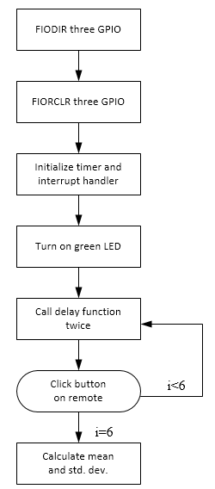

Figure 5: Flow chart for the high level of implementation

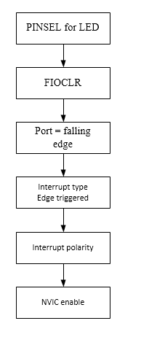
Figure 6: Flow chart for the low level of implementation of the initialization of the interrupt
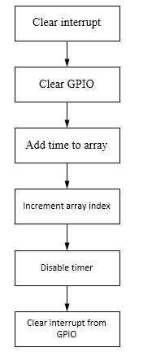

Figure 7: Flow chart for the low level of implementation of the interrupt handler
The pseudo code for the program is as follows:
Int main()
{
FIODIR for port 2 pins
FIOSET test status LED
For(i=0;i<6;i=i+1)
{
Initialize timer;
Reset_timer();
Enable_timer();
Set GPIO yellow LED on
Generate random time
Delay function()
Clear GPIO yellow LED
Delay function()
Print “Press button”
External interrupt initialization()
}
Mean and deviation calculation()
FIOCLR test status LED
Print Done
Return 0;
}

4. Testing and Verification

The program used in the project “extint.c” was modified for using the current GPIO pins of in this project. The debug function on the NXP Xpresso IDE was used to verify the functionality of the LEDs and correct path the program should take. The voltage differences at the input and output pins were checked to verify correct voltages and account for current. Within the Xpresso IDE, the console outputs the times where a button on the remote control should be pressed to trigger an interrupt response for the test.

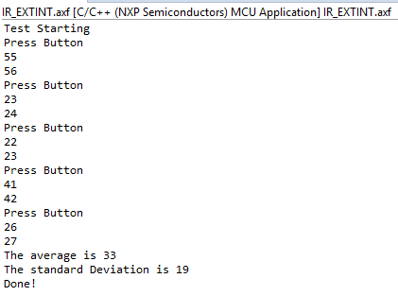

Figure 7: LPCXpresso console output of program
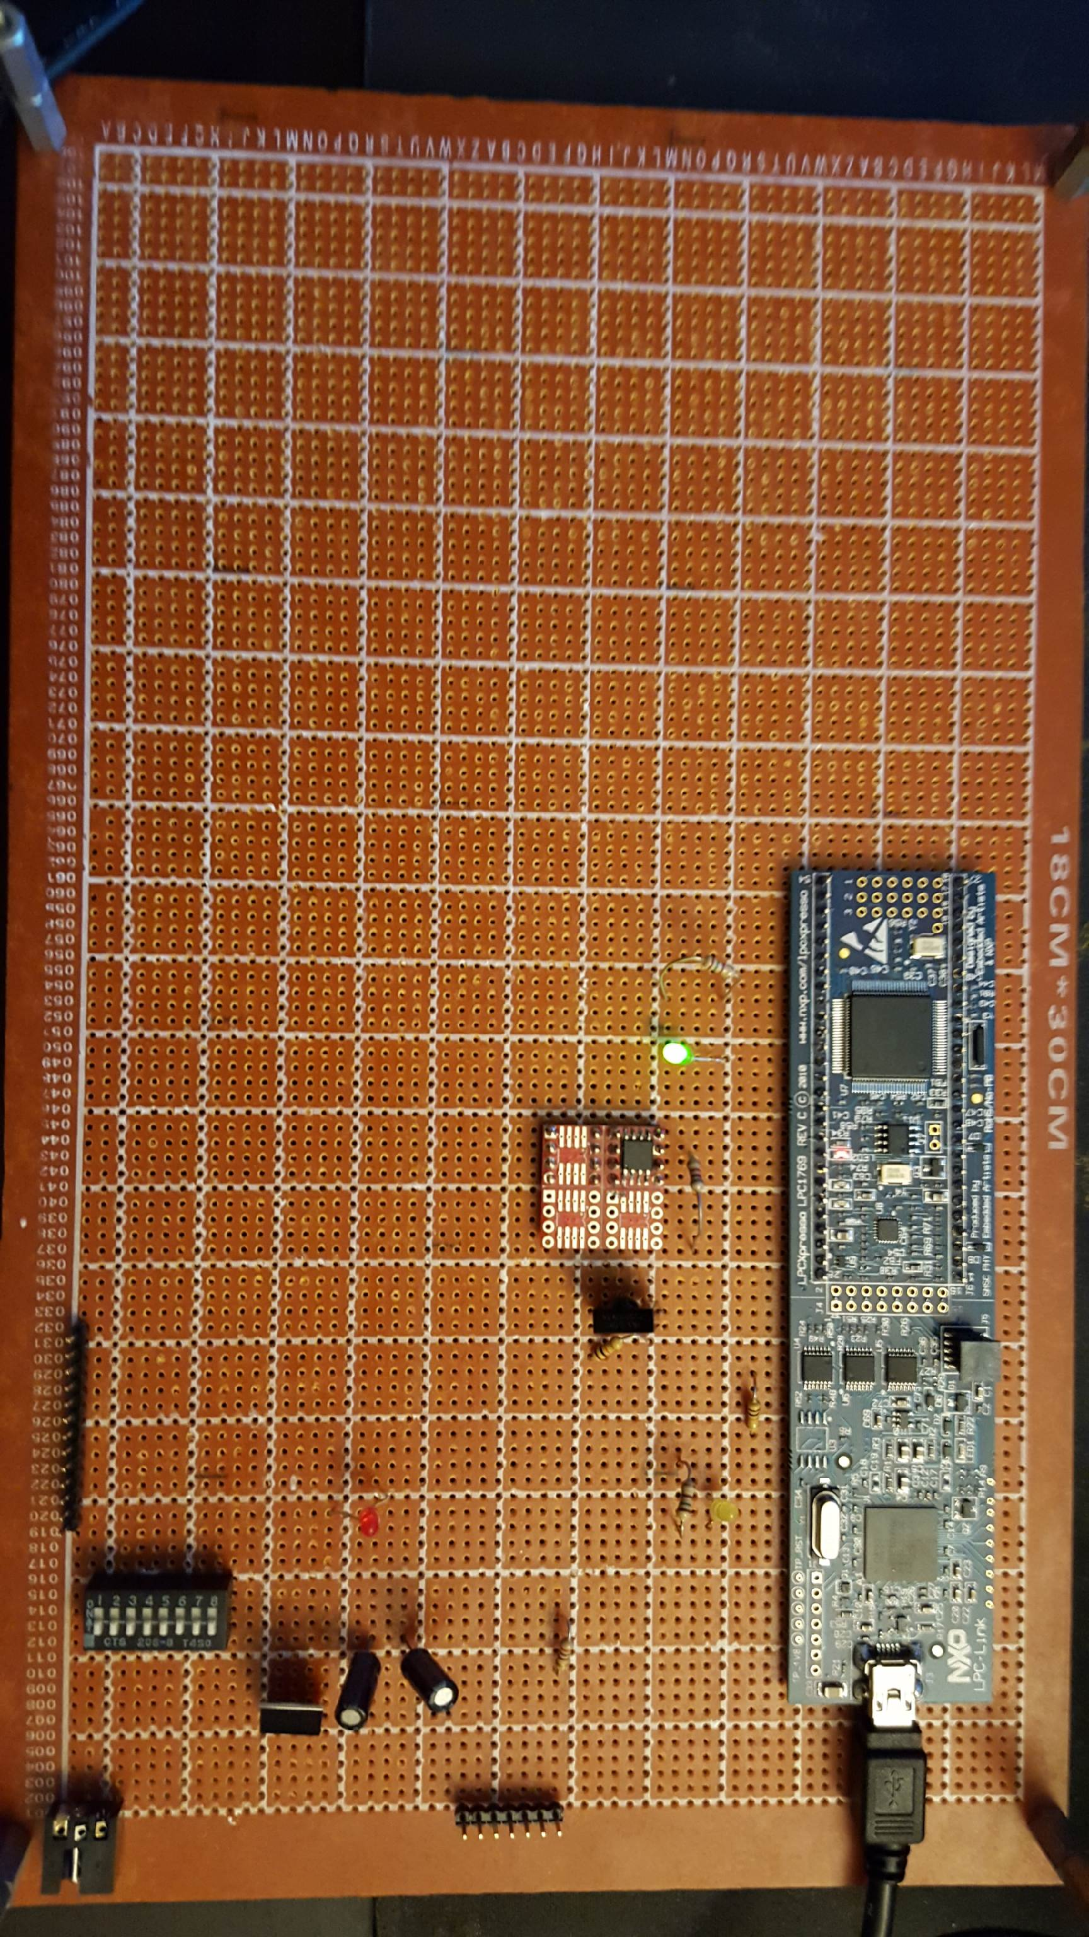
Figure 8: Picture of prototype board with TSOP 31236 installed and the test initialized.
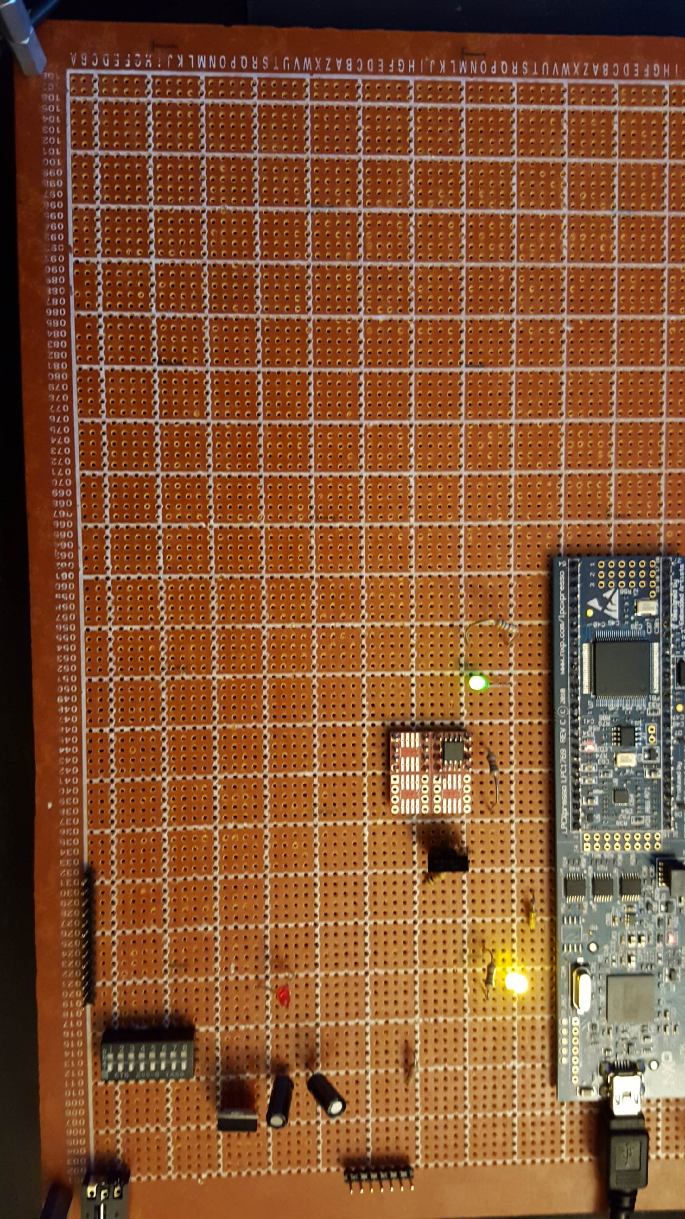
Figure 9: Picture of prototype board with TSOP 31236 installed and the test in process.

5. Conclusion
The starting, stopping and resetting of the timer was the most difficult portion encountered in this project. Making sure only one LED turns off every time an interrupt is encountered was time consuming to configure and test. The voltage supply was taken from the 3.3V LPC module pin because powering all of the circuits using the USB plug in was the most efficient method of power. To fully utilize the timer, a list of instructions for one of the timers on the LPC module was used. Within the program there was a lot of function calling between functions. There wasn’t much detail in the comments for each function and the code needed to be reviewed for a long time to understand the process.

6. Acknowledgement
Dr. Harry Li provided information on interrupts and instructions for programming. Assistant Gautam Saily provided help with circuit trouble shooting on both parts of the project and also gave advice for taking more effective approaches to building the circuits. My classmates also helped by providing solutions to technical challenges that they personally ran into, so I had different ways fixing the problems encountered throughout the project.

7. References

[1] H. Li, “Author Guidelines for CMPE 146/242 Project Report”, Lecture Notes of CMPE 146/242, Computer Engineering Department, College of Engineering, San Jose State University, March 6, 2006, pp. 1.

8. Appendix

Table I: Bill of Materials
Item # | Description | Notes
1 | Wall Mount
2 | LM7805ct | +7V in/5V out
3 | Red LED
4 | DIP switch | 2nd for LM 4th for GPIO circuit
5 | LPC1769 | CPU Module
6 | Resistors | 3(150,270,10k)
7 | Capacitors | 210µF
8 | Wire Wrapping Tool
9 | Solder
10 | 28 Gauge Wire
11 | AT45 | SPI flash memory

Table II: Pin Layout for LPC 1769
Pin | Description | Notes
J6-1 | Ground
J6-2 | Vcc | 5V
J6-28 | VIO_3V3X | 3.3V output
J6-42 | GPIO output | Yellow LED
J6-46 | GPIO output | Green LED
J6-51 | TSOP Output

Table III: Pin Layout for TSOP 31236
Pin | Description | Notes
1 | Ground
2 | Vs | Voltage Supply
3 | Output | J6-51

Table IV: Pin Layout for AT45
Pin | Description | Notes
1 | SI(I/O2) | Slave in
2 | SCK | Serial clock
4 | CS | nCS
6 | Vcc | Power supply
7 | GND | Ground
8 | SO(I/O1) | Slave out

Source Code:

IR_ExInt.c (Main source file)

#ifdef __USE_CMSIS
#include "LPC17xx.h"
#include "timer.h"
#include "uart.h"
#include "extint.h"
#include "type.h"
#include <time.h>
#endif
#include <cr_section_macros.h>
#include <stdio.h>
#define IRC_OSC ( 4000000UL)
uint32_t i, j;
int x;
extern uint32_t timer0_m0_counter,
timer1_m0_counter;
extern uint32_t timer0_m1_counter,
timer1_m1_counter;

int main(void)
{
printf("Test Starting\n"); // Force the counter to be placed into memory
//volatile static int i = 0 ; // Enter an infinite loop, just incrementing a counter
LPC_GPIO2->FIODIR = 0x000000FF; /* P2.xx defined as Outputs */
//LPC_GPIO2->FIOCLR = 0x000000FF; /* turn off all the LEDs */
//GPIO_INT();
int i = 0;
//int a = 0;
LPC_GPIO2->FIOSET = 1 << 4;

for(i = 0; i < 6; i++)
{
init_timer(0, 2000);
reset_timer(0);
enable_timer(0);
//x= rand() % 5000;
LPC_GPIO2->FIOSET = 1 << 0; //YELLOW LED
x= rand() % 7500;
delayMs(1, x);
//x= rand() % 5000;
LPC_GPIO2->FIOCLR = 1<< 0; //YELLOW LED
delayMs(1, x);
if(i<=4)
{
printf("Press Button\n", x);
}
EINTInit();
}
meananddeviation();
LPC_GPIO2->FIOCLR = 1 << 4;
printf("Done!\n");
return 0 ;
}

Extint.c

#include "lpc17xx.h"
#include "type.h"
#include "extint.h"
#include "timer.h"
#include "uart.h"
#include <time.h>
#include "math.h"
//#include "stdio.h"
volatile uint32_t eint0_counter;
extern uint32_t timer0_m0_counter, timer1_m0_counter;
extern uint32_t timer0_m1_counter, timer1_m1_counter;
int SumArray[5];
int i=0;
void meananddeviation()
{
int average, sum, sum2, stddev;
sum = 0;
average = 0;

for(i = 0; i < 6; i++)
{
sum += SumArray[i];
}
average = sum/6;
printf("The average is %d\n", average);

for(i = 0; i < 6; i++)
{
sum2 += ((SumArray[i] - average)*(SumArray[i] - average));
}
sum2=sum2/6;

stddev = sqrt(sum2);
printf("The standard Deviation is %d\n", stddev);
}

void EINT0_IRQHandler (void)
{
LPC_SC->EXTINT = EINT0; /* clear interrupt */

LPC_GPIO2->FIOCLR = 1 << 0;

printf("%d\n",timer0_m0_counter);
SumArray[i] = timer0_m0_counter;
i++;
disable_timer(0);

LPC_GPIOINT->IO2IntClr = 0xFFFFFFFF;
LPC_GPIOINT->IO0IntClr = 0xFFFFFFFF;
}
uint32_t EINTInit( void )
{
LPC_PINCON->PINSEL4 = 0x00100000; /* set P2.10 as EINT0 and P2.0~7 GPIO output */

//LPC_GPIO2->FIODIR = 0x000000FF; /* port 2, bit 0~7 only */
//LPC_GPIO2->FIOCLR = 0x000000FF; /* turn off LEDs */

LPC_GPIO2->FIOCLR = 1 << 0;
LPC_GPIOINT->IO2IntEnF = 0x200; /* Port2.10 is falling edge. */
LPC_SC->EXTMODE = EINT0_EDGE; /* INT0 edge trigger */
LPC_SC->EXTPOLAR = 0; /* INT0 is falling edge by default */

NVIC_EnableIRQ(EINT0_IRQn);
return( TRUE );
}

Timer.c

#include "lpc17xx.h"
#include "type.h"
#include "timer.h"

volatile uint32_t timer0_m0_counter = 0;
volatile uint32_t timer1_m0_counter = 0;
volatile uint32_t timer2_m0_counter = 0;
volatile uint32_t timer3_m0_counter = 0;
volatile uint32_t timer0_m1_counter = 0;
volatile uint32_t timer1_m1_counter = 0;
volatile uint32_t timer2_m1_counter = 0;
volatile uint32_t timer3_m1_counter = 0;

volatile uint32_t timer0_capture0 = 0;
volatile uint32_t timer1_capture0 = 0;
volatile uint32_t timer2_capture0 = 0;
volatile uint32_t timer3_capture0 = 0;
volatile uint32_t timer0_capture1 = 0;
volatile uint32_t timer1_capture1 = 0;
volatile uint32_t timer2_capture1 = 0;
volatile uint32_t timer3_capture1 = 0;

/*****************************************************************************
** Function name: delayMs
**
** Descriptions: Start the timer delay in milo seconds
** until elapsed
**
** parameters: timer number, Delay value in milo second
**
** Returned value: None
**
*****************************************************************************/
void delayMs(uint8_t timer_num, uint32_t delayInMs)
{
if ( timer_num == 0 )
{
LPC_TIM0->TCR = 0x02; /* reset timer */
LPC_TIM0->PR = 0x00; /* set prescaler to zero */
LPC_TIM0->MR0 = delayInMs * (9000000 / 1000-1);
LPC_TIM0->IR = 0xff; /* reset all interrrupts */
LPC_TIM0->MCR = 0x04; /* stop timer on match */
LPC_TIM0->TCR = 0x01; /* start timer */

/* wait until delay time has elapsed */
while (LPC_TIM0->TCR & 0x01);
}
else if ( timer_num == 1 )
{
LPC_TIM1->TCR = 0x02; /* reset timer */
LPC_TIM1->PR = 0x00; /* set prescaler to zero */
LPC_TIM1->MR0 = delayInMs * (9000000 / 1000-1);
LPC_TIM1->IR = 0xff; /* reset all interrrupts */
LPC_TIM1->MCR = 0x04; /* stop timer on match */
LPC_TIM1->TCR = 0x01; /* start timer */

/* wait until delay time has elapsed */
while (LPC_TIM1->TCR & 0x01);
}
return;
}

/******************************************************************************
** Function name: Timer0_IRQHandler
**
** Descriptions: Timer/Counter 0 interrupt handler
**
** parameters: None
** Returned value: None
**
******************************************************************************/
void TIMER0_IRQHandler (void)
{
if ( LPC_TIM0->IR & (0x1<<0) )
{
LPC_TIM0->IR = 0x1<<0; /* clear interrupt flag */
timer0_m0_counter++;
}
if ( LPC_TIM0->IR & (0x1<<1) )
{
LPC_TIM0->IR = 0x1<<1; /* clear interrupt flag */
timer0_m1_counter++;
}
if ( LPC_TIM0->IR & (0x1<<4) )
{
LPC_TIM0->IR = 0x1<<4; /* clear interrupt flag */
timer0_capture0++;
}
if ( LPC_TIM0->IR & (0x1<<5) )
{
LPC_TIM0->IR = 0x1<<5; /* clear interrupt flag */
timer0_capture1++;
}
return;
}

/******************************************************************************
** Function name: Timer1_IRQHandler
**
** Descriptions: Timer/Counter 1 interrupt handler
**
** parameters: None
** Returned value: None
**
******************************************************************************/
void TIMER1_IRQHandler (void)
{
if ( LPC_TIM1->IR & (0x1<<0) )
{
LPC_TIM1->IR = 0x1<<0; /* clear interrupt flag */
timer1_m0_counter++;
}
if ( LPC_TIM1->IR & (0x1<<1) )
{
LPC_TIM1->IR = 0x1<<1; /* clear interrupt flag */
timer1_m1_counter++;
}
if ( LPC_TIM1->IR & (0x1<<4) )
{
LPC_TIM1->IR = 0x1<<4; /* clear interrupt flag */
timer1_capture0++;
}
if ( LPC_TIM1->IR & (0x1<<5) )
{
LPC_TIM1->IR = 0x1<<5; /* clear interrupt flag */
timer1_capture1++;
}
return;
}

/******************************************************************************
** Function name: enable_timer
**
** Descriptions: Enable timer
**
** parameters: timer number: 0 or 1 or 2 or 3
** Returned value: None
**
******************************************************************************/
void enable_timer( uint8_t timer_num )
{
if ( timer_num == 0 )
{
LPC_TIM0->TCR = 1;
}
else if ( timer_num == 1 )
{
LPC_TIM1->TCR = 1;
}
else if ( timer_num == 2 )
{
LPC_TIM2->TCR = 1;
}
else if ( timer_num == 3 )
{
LPC_TIM3->TCR = 1;
}
return;
}

/******************************************************************************
** Function name: disable_timer
**
** Descriptions: Disable timer
**
** parameters: timer number: 0 or 1 oe 2 or 3
** Returned value: None
**
******************************************************************************/
void disable_timer( uint8_t timer_num )
{
if ( timer_num == 0 )
{
LPC_TIM0->TCR = 0;
}
else if ( timer_num == 1 )
{
LPC_TIM1->TCR = 0;
}
else if ( timer_num == 2 )
{
LPC_TIM2->TCR = 0;
}
else if ( timer_num == 3 )
{
LPC_TIM2->TCR = 0;
}
return;
}

/******************************************************************************
** Function name: reset_timer
**
** Descriptions: Reset timer
**
** parameters: timer number: 0 or 1 or 2 or 3
** Returned value: None
**
******************************************************************************/
void reset_timer( uint8_t timer_num )
{
uint32_t regVal;

if ( timer_num == 0 )
{
regVal = LPC_TIM0->TCR;
regVal |= 0x02;
LPC_TIM0->TCR = regVal;
}
else if ( timer_num == 1 )
{
regVal = LPC_TIM1->TCR;
regVal |= 0x02;
LPC_TIM1->TCR = regVal;
}
else if ( timer_num == 2 )
{
regVal = LPC_TIM2->TCR;
regVal |= 0x02;
LPC_TIM2->TCR = regVal;
}
else if ( timer_num == 3 )
{
regVal = LPC_TIM3->TCR;
regVal |= 0x02;
LPC_TIM3->TCR = regVal;
}
return;
}

/******************************************************************************
** Function name: init_timer
**
** Descriptions: Initialize timer, set timer interval, reset timer,
** install timer interrupt handler
**
** parameters: timer number and timer interval
** Returned value: true or false, if the interrupt handler can't be
** installed, return false.
**
******************************************************************************/
uint32_t init_timer ( uint8_t timer_num, uint32_t TimerInterval )
{
uint32_t pclkdiv, pclk;

if ( timer_num == 0 )
{
timer0_m0_counter = 0;
timer0_m1_counter = 0;
timer0_capture0 = 0;
timer0_capture1 = 0;
LPC_SC->PCONP |= (0x01<<1);
#if TIMER_MATCH
LPC_PINCON->PINSEL3 &= ~((0x3<<24)|(0x3<<26));
LPC_PINCON->PINSEL3 |= ((0x3<<24)|(0x3<<26));
#else
LPC_PINCON->PINSEL3 &= ~((0x3<<20)|(0x3<<22));
LPC_PINCON->PINSEL3 |= ((0x3<<20)|(0x3<<22));
#endif
LPC_TIM0->IR = 0x0F; /* Clear MATx interrupt include DMA request */

/* By default, the PCLKSELx value is zero, thus, the PCLK for
all the peripherals is 1/4 of the SystemFrequency. */
/* Bit 2~3 is for TIMER0 */
pclkdiv = (LPC_SC->PCLKSEL0 >> 2) & 0x03;
switch ( pclkdiv )
{
case 0x00:
default:
pclk = SystemCoreClock/4;
break;
case 0x01:
pclk = SystemCoreClock;
break;
case 0x02:
pclk = SystemCoreClock/2;
break;
case 0x03:
pclk = SystemCoreClock/8;
break;
}
LPC_TIM0->PR = pclk/1000000; /* set prescaler to get 1 M counts/sec */

LPC_TIM0->MR0 = TIME_INTERVALmS * 10; /* Set up 10 mS interval */
LPC_TIM0->MR1 = TIME_INTERVALmS * 10; /* Set up 10 mS interval */
#if TIMER_MATCH
LPC_TIM0->EMR &= ~(0xFF<<4);
LPC_TIM0->EMR |= ((0x3<<4)|(0x3<<6));
#else
/* Capture 0 and 1 on rising edge, interrupt enable. */
LPC_TIM0->CCR = (0x1<<0)|(0x1<<2)|(0x1<<3)|(0x1<<5);
#endif
LPC_TIM0->MCR = (0x3<<0)|(0x3<<3); /* Interrupt and Reset on MR0 and MR1 */
NVIC_EnableIRQ(TIMER0_IRQn);
return (TRUE);
}
else if ( timer_num == 1 )
{
timer1_m0_counter = 0;
timer1_m1_counter = 0;
timer1_capture0 = 0;
timer1_capture1 = 0;
LPC_SC->PCONP |= (0x1<<2);
#if TIMER_MATCH
LPC_PINCON->PINSEL3 &= ~((0x3<<12)|(0x3<<18));
LPC_PINCON->PINSEL3 |= ((0x3<<12)|(0x3<<18));
#else
LPC_PINCON->PINSEL3 &= ~((0x3<<4)|(0x3<<6));
LPC_PINCON->PINSEL3 |= ((0x3<<4)|(0x3<<6));
#endif
LPC_TIM1->IR = 0x0F; /* Clear MATx interrupt include DMA request */
/* By default, the PCLKSELx value is zero, thus, the PCLK for
all the peripherals is 1/4 of the SystemFrequency. */
/* Bit 4~5 is for TIMER0 */
pclkdiv = (LPC_SC->PCLKSEL0 >> 4) & 0x03;
switch ( pclkdiv )
{
case 0x00:
default:
pclk = SystemCoreClock/4;
break;
case 0x01:
pclk = SystemCoreClock;
break;
case 0x02:
pclk = SystemCoreClock/2;
break;
case 0x03:
pclk = SystemCoreClock/8;
break;
}
LPC_TIM1->PR = pclk/1000000; /* set prescaler to get 1 M counts/sec */
LPC_TIM1->MR0 = TIME_INTERVALmS * 10; /* Set up 10 mS interval */
LPC_TIM1->MR1 = TIME_INTERVALmS * 10; /* Set up 10 mS interval */
#if TIMER_MATCH
LPC_TIM1->EMR &= ~(0xFF<<4);
LPC_TIM1->EMR |= ((0x3<<4)|(0x3<<6));
#else
/* Capture 0/1 on rising edge, interrupt enable. */
LPC_TIM1->CCR = (0x1<<0)|(0x1<<2)|(0x1<<3)|(0x1<<5);
#endif
LPC_TIM1->MCR = (0x3<<0)|(0x3<<3); /* Interrupt and Reset on MR0 and MR1 */
NVIC_EnableIRQ(TIMER1_IRQn);
return (TRUE);
}
return (FALSE);
}

